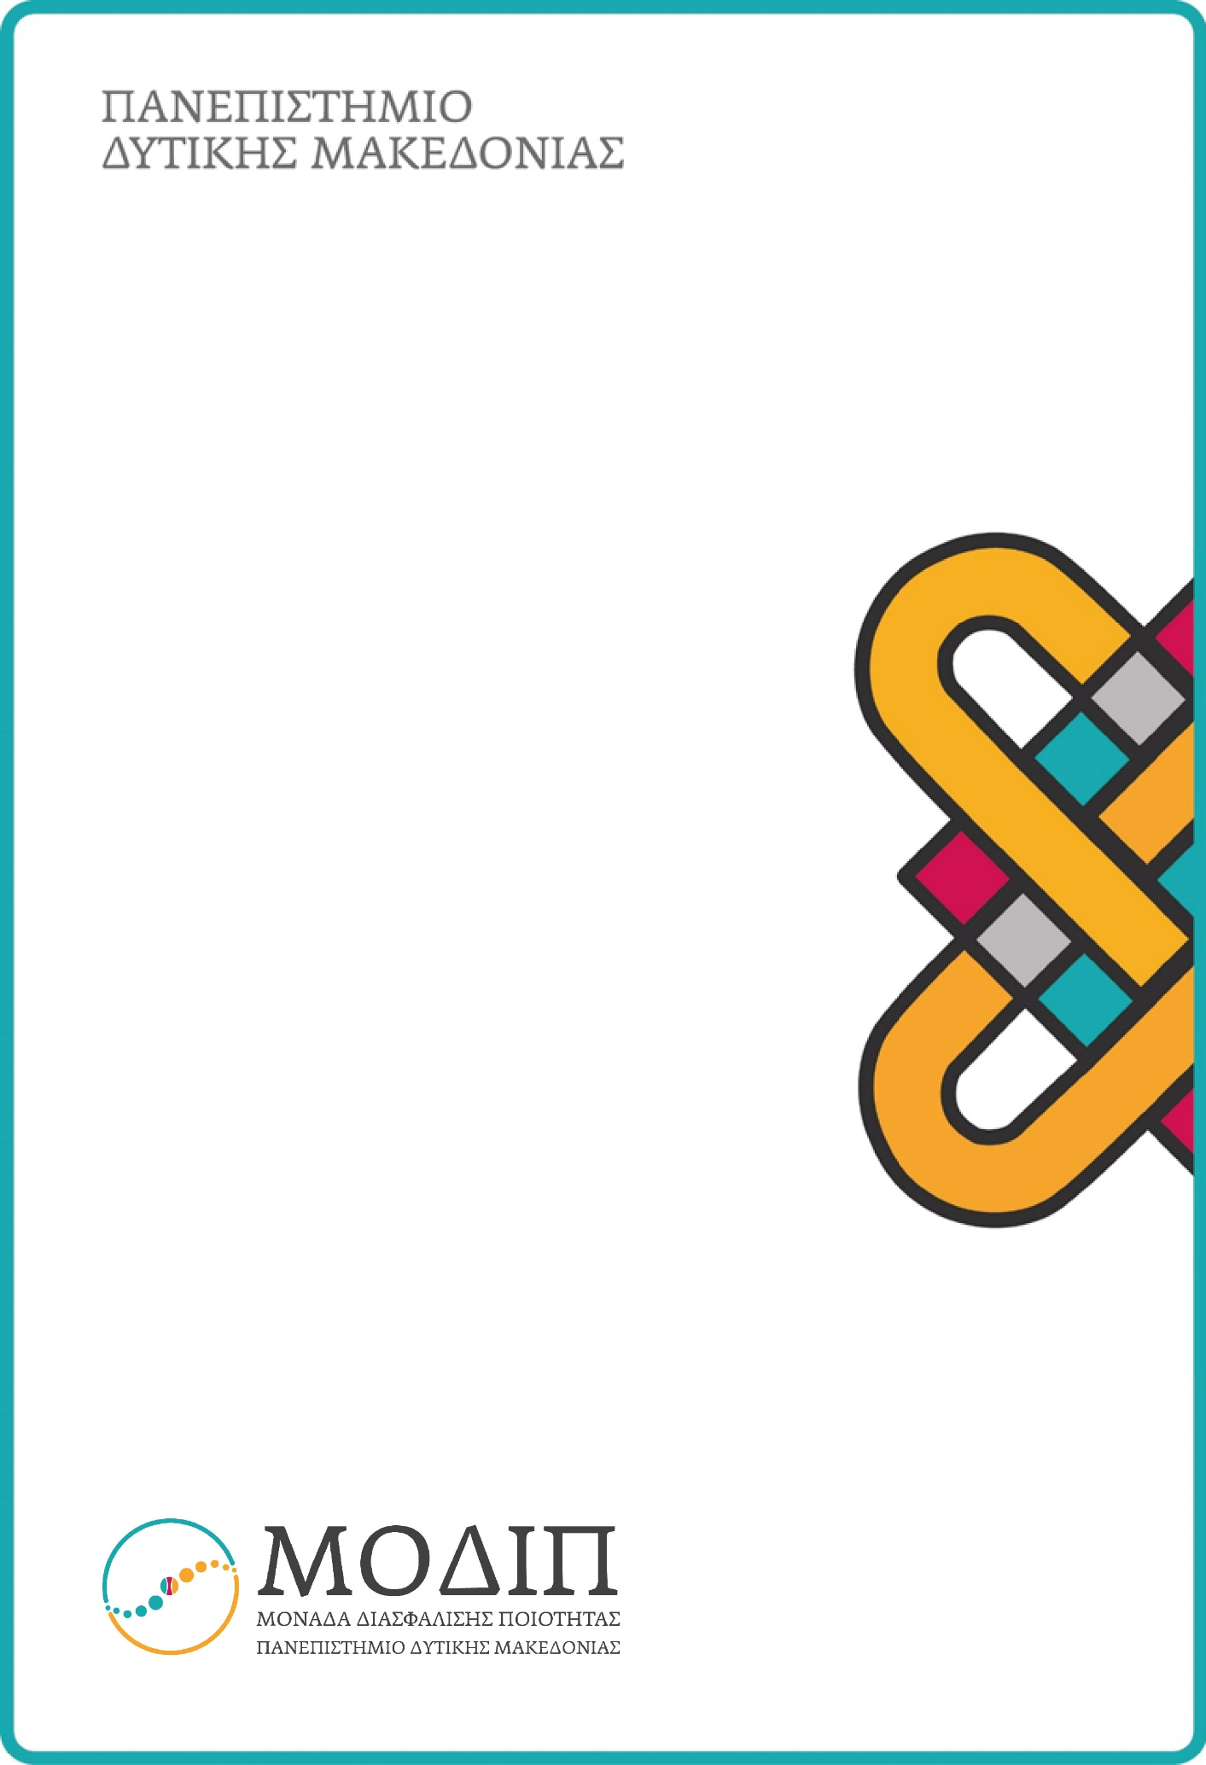
UoWM Support Units and Services

Table of Contents

1. Accessibility Centre for Students of Vulnerable Social Groups (ACfSoVSG) (Greek MYFEO) 4
2. Career Office 4
3. Student Advocate 5
4. Erasmus Office 6
5. Studies, Internship and Career Office 7
6. Technology Transfer Office 7
7. Holistic Care 9
8. Library and Information Center Directorate 9
9. Department of IT/Informatics-Networks Department 9
9.1 Electronic Mail 9
9.2 Mailing lists 9
9.3 Access to the Student Register 10
9.4 Synchronous and asynchronous long-distance learning 10
9.5 Online Application System 10
9.6 Website Hosting Service 10
9.7 VPN Connection 10
9.8 Wireless Access (Wi-Fi) 11
9.9 Eduroam 11
9.10 File Sharing Service 11
9.11 Institutional Libraries 11
9.12 Insitutional Depository 11
9.13 Q.A.U. Information System 12
9.14 G Suite for Education Service 12
9.15 Office 365 / DILOS 365 Service 12
9.16 Telephony using smart devices or a computer (Voip) 12
9.17 Malfunction and technical work notification system 12
10. Academic Advisor 13
11. Management of Student Complaints 13
12. Sports Facilities 14
13. Student Groups and Associations 14
14. Student Restaurants 14
15. Equal Access Unit for People with Disabilities and Special Educational Needs 15
16. Avoiding Discrimination 15

1. Accessibility Centre for Students of Vulnerable Social Groups (ACfSoVSG) (Greek MYFEO)
The Accessibility Centre for Students of Vulnerable Social Groups (ACfSoVSG) https://myfeo.uowm.gr/ is under the responsibility of the Directorate of Academic Affairs & Student Welfare, and in particular the Department of Student Welfare. The Psychological and Counseling Support Structure (P.C.S.S.) which is staffed by five psychologists also belongs to (ACfSoVSG). ACfSoVSG’s goal is the equal participation in higher education and the increase in the rate of timely completion of studies of students who belong to Vulnerable Social Groups (VSG); in particular, students with disabilities, as well as those from particularly low-income classes, through the strengthening of relevant supporting units. The Psychological and Counseling Support Structure (P.C.S.S.) belongs to ACfSoVSG, which is based in the five cities where UoWM has Departments (Grevena, Kastoria, Kozani, Ptolemaida, Florina) and provides individual and group psychological support services and consulting. At the same time, in order to ensure the accessibility of all Students from Socially Vulnerable Groups (SSVG) to the premises of the University of Western Macedonia (UoWM), a systematic check is carried out by a competent civil engineer of the institution's infrastructure in each city where UoWM has departments. Finally, electronic accessibility and information accessibility is supported by the open collection of Supportive IT Technologies ATHENA: http://athena.uoa.gr/.

2. Career Office
The University’s Career Office (https://career.uowm.gr/) is the bridge that connects students and graduates with the wider scientific academic and professional environment, advising and guiding graduates on the one hand in issues related to the continuation of studies in Greece and abroad, and on the other hand, to smoother access to the labor market. It provides specialized consulting and support on topics such as the preparation and formatting of a Curriculum Vitae, preparation for a job interview, preparation of a cover letter, preparation of a self-descriptive report (motivation letter) for postgraduate applications and advice on job search techniques and resources, techniques for joining the labor market, decision-making techniques aiming at the successful interconnection of graduates with the labor market, strengthening the degree of extroversion of the University of Western Macedonia in the modern work and social environment.
In addition, the Career Office of the University of Western Macedonia provides information on Postgraduate Programs, sources of financial support, scholarships, awards, job positions offered in Greece and abroad, lifelong learning programs, seminars, conferences, Volunteer Employment Programs.
On the new website of the UoWM Career Office (career.uowm.gr) it is possible to post job and internship position advertisements with practical navigation functions and a concise presentation of the most important information. In addition, the creation of an employer account and the maintenance of a company profile with independent posting and management of the company's jobs are supported. The gradual creation of candidates' profiles with biographical data, the connection with a unified login and direct communication functions between employers and candidates have also been foreseen and supported. Last but not least, there is a daily update on academic issues such as invitations to postgraduate programs, scholarships, lifelong learning programs and doctoral studies.
Finally, the Career Office operates an alumni platform (https://alumni.uowm.gr/), where UoWM alumni are given the opportunity to connect with each other both by criteria such as their postgraduate graduate program and geographically. In addition, the opportunity to search for investors for business ideas from the alumni, is provided. Through the platform, the postgraduate program is given the possibility to export statistical information about its graduates (e.g. absorption in the labor market).

3. Student Advocate
The Student Advocate (https://www.uowm.gr/dioikisi/domes/synigoros-toy-foititi-toy-pdm/), aims to mediate between students and professors or administrative services of the institution, to observe legality in framework of academic freedom, dealing with maladministration phenomena and safeguarding the orderly operation of the institution. The Student Advocate has no authority in matters of exams and students' grades.
The Student Advocate investigates cases, ex officio or following a student's report, and mediates with the institution's competent bodies for their resolution. It can request from the services of the institution any information, document, or other evidence on the case, examine persons, perform an autopsy, and order an expert opinion. If the Student Advocate ascertains that in a specific case the law is not respected, that there are phenomena of maladministration or that the orderly operation of the institution is disturbed, he draws up a conclusion about which he notifies the professor concerned or the competent administrative department and the student who submitted the report and mediates with each convenient way to solve the problem. The Student Advocate may, by his act, place in the file a report that is considered clearly vague, unfounded, or unsupported, while in the event that he considers that there are indications of a disciplinary offense, he forwards the case to the competent disciplinary body.

4. Erasmus Office
The Erasmus Office of the University of Western Macedonia manages principally the European Erasmus+ program and specifically the mobility of students and staff to and from Tertiary Institutions and Host Agencies abroad. The main objective of the Erasmus Office is to contribute decisively to the internationalization of the Foundation's studies, to the promotion of intercultural understanding and to extroversion. The Erasmus Office of the University of Western Macedonia, seeking to be a shareholder and communicator of European and international developments, has set a series of related actions (see also https://erasmus.uowm.gr).

5. Studies, Internship and Career Office
Under the responsibilities of the above-mentioned office (https://internship.uowm.gr/) are included in particular:
- The consideration of the timely preparation of the printed material for issues related to the Office of Studies, Internship and Career in cooperation with the Secretariats of the Academic Units and the Publications Office as well as the library.
- The consideration of students' internships in collaboration with the Chairpersons and Secretariats of the Academic Units, with the main aim of efficient student internships and the effective connection of education with production.
- The consideration of gathering information that will be processed and disseminated to students for the needs of specific companies in human resources.
- Advising students on the possibilities that exist and the actions they should take in order to have positive results in their efforts to find a job position.
- The consideration of business contact with students who have expressed an interest in working in a specific field of interest.
- Informing students about Special Continuing Education Programs.Στις αρμοδιότητες του ανωτέρω Τμήματος (https://internship.uowm.gr/) υπάγονται ιδίως:

6. Technology Transfer Office
The purpose of the Technology Transfer Office (https://tto.uowm.gr/en/home/) is to register and protect new research results and knowledge resulting from University activities, intellectual property through patents, diplomas modification and certificates of utility models of expertise, the granting of licenses for the use of rights in the private and public sector for their commercial exploitation, the finding of funding for the University's research activity from domestic and European bodies, as well as the creation of spin-offs.

The Technology Transfer Office of the University of Western Macedonia:
- offers educational activities to the research and academic community of the University. By organizing seminars, workshops and other events, the Office aims at informing researchers about the possibilities of exploiting their research, the possible collaborations with local and domestic companies to promote research and innovation and the general interconnection of the research laboratory with the labor market and entrepreneurship.
- organizes events to inform the academic community of the University about upcoming calls for proposals both at the domestic and international – European level. Through seminars, it promotes the training of researchers in matters of submitting proposals, the participation of researchers in collaborations with Greek universities and national and international research and development bodies.
- provides support to the research and academic community of the University by proceeding to the recording of research results, the search and highlighting of possible opportunities for the commercial exploitation of these results as well as the search for possible financial tools for new research at the University. The promotion of entrepreneurship in the university community is achieved through the establishment of start-up companies and the advisory support for securing Intellectual Property Rights.
- aids university researchers in identifying technological demand and needs and in identifying appropriate infrastructures for the development of research and innovation by creating and making information material available and participating in national and international development and innovation forums as well as by networking with the labor market.

7. Holistic Care
In the context of the Holistic approach of the UoWM (https://holistic.uowm.gr/) to maintain health and more broadly, to support biological and social well-being, an integrated network of actions has been designed and implemented to support all human resources of the Institution and the improvement of its daily living conditions. More specifically, sports and cultural programs (learning yoga, tennis, martial arts, traditional & Latin dances, chess, theater groups, operation of gymnasiums, rowing groups, swimming pool activities, etc.) are implemented either in privately owned facilities of the University or in the premises of cooperating local bodies. At the same time, initiatives are taken to encourage the culture of social contribution and volunteerism while targeted awareness-raising actions are also carried out.

8. Library and Information Center Directorate
UoWM has Library spaces in all cities (https://library.uowm.gr/). Borrowing, lending and user education services are provided in information retrieval. In addition, in the library areas there are IT facilities (computers with internet access) as well as photocopiers. Access to the library's digital services (electronic journals, books, repositories, bibliographic bases and information materials) is provided through institutional certification.

9. Department of IT/Informatics-Networks Department
The online services provided to students (https://noc.uowm.gr/www/services/) include:

9.1 Electronic Mail
Provision of an Institutional email account.

9.2 Mailing lists
Provision of installation and operation of a mailing list system in order to facilitate communication between user groups belonging to the University's academic community.
An email list is a directory of email addresses. When a message is sent to a mailing list, copies of the message are distributed to every email address on the mailing list.

9.3 Access to the Student Register
Access to the personal record for course registrations, viewing registered scores, making applications for issuing study certificates, etc.

9.4 Synchronous and asynchronous long-distance learning
Integrated systems and platforms are provided at UoWM to support modern and asynchronous distance education.

9.5 Online Application System
The submission of specific types of applications submitted by students to the central administrative services is done electronically, with a special platform created by the IT Department.

9.6 Website Hosting Service
The IT Department, in order to better serve the members of the University, has resources for hosting dynamic websites on the UoWM network. The goal is to provide flexible hosting services to UoWM units and actions that require reliability and security in their website presence on the internet, with know-how and equipment that they cannot provide themselves using the means available to them.

9.7 VPN Connection
The VPN (Virtual Private Network) service enables to the users of the institution who already have an internet connection (e.g. DSL connection) to obtain a University IP address from any place they may connect, along with any rights that come with it, e.g. access to internal electronic services of the University, access to electronic resources via HEAL-LINK, etc.

9.8 Wireless Access (Wi-Fi)
UoWM provides the members of the Academic Community, as well as visitors, with the possibility of wireless access to the internet through a Wi-Fi wireless local network infrastructure. Wi-Fi service is offered in all University buildings.

9.9 Eduroam
The University of Western Macedonia participates in eduroam, the international Wi-Fi roaming service which in our country is operated and coordinated by the National Research and Technology Network and in which educational institutions from all over the world participate.

9.10 File Sharing Service
The File Exchange Service operates at https://share.uowm.gr, with the assistance of which it is possible to send large files (currently up to 1000MB in size) to other users.
The Secure File Sending Service operates at https://send.uowm.gr, with the assistance of which it is possible to securely send large files to other users.

9.11 Institutional Libraries
The University of Western Macedonia operates a single catalog of the Library of the University of Western Macedonia.

9.12 Insitutional Depository
The Institutional Depository of Scientific Works (Greek IKEE) operating at UoWM, is the Digital Library of the University of Western Macedonia. IKEE collects digital/electronic material in order to support the educational and research process, lifelong learning, as well as the preservation and maintenance of recorded knowledge.
As a digital library, it provides, through its collections, hard-to-find printed and audiovisual material, which makes it one of the most convenient means of preserving recent cultural and academic heritage.
As an institutional repository, it aims at the gathering, digital preservation, highlighting and promotion of works prepared within the study programs of the university's departments, as well as other publications published by the University of Western Macedonia.

9.13 Q.A.U. Information System
In the Information System of Q.A.U., students fill in the electronic questionnaires for the assessment of teaching work. The entire process of completing questionnaires is conducted online, ensuring the anonymity of the participants.

9.14 G Suite for Education Service
The University of Western Macedonia participates in the G Suite for Education program of the Google company. G Suite for Education services are a set of services offered free of charge to educational institutions, with the following main services: Classroom, Gmail, Drive, Calendar, Docs, Sheets, Slides, Sites.

9.15 Office 365 / DILOS 365 Service
Through the DILOS 365 service, access is gained to Microsoft cloud applications, which include Office 365 Online, One Drive (1TB), Skype for Business, etc.

9.16 Telephony using smart devices or a computer (Voip)
The service provides University members who have an institutional account with the ability to make calls from an electronic device (smartphone or computer) to: University landlines, other users connected to the same service at the time, long-distance telephones of affiliated institutions in the GUNET/EDET VoIP network.

9.17 Malfunction and technical work notification system
The University operates an integrated electronic system for recording and monitoring requests for breakdowns, malfunctions, maintenance and general technical problems. The electronic ticketing system can be found on the website of the Directorate of Technical Services and Automation at the link: https://service.uowm.gr.

10. Academic Advisor
The Academic Advisor provides the student with the necessary support to cope with the demands of his/her studies at the University.
The Academic Advisor makes sure to have meetings at regular intervals with the students he/she has assigned. His/her duties include, among others:
- Identifying the needs and interests of the student, supporting the student's inclinations and skills and advising him/her to follow the fields that best suit him/her.
- Facilitating the student’s transition from secondary to higher education.
- Facilitating the student's contacts with the university authorities and administrative bodies and services.
- Supporting the preparation of the student’s individual six-month study program and the definition of the subject of his/her thesis.
- Providing information on issues related to the professional orientation of the student, based on his/her interests and the development of his/her academic career (e.g. postgraduate studies in Greece and abroad).
- Identifying students who owe a lot of courses, caring for them and devising a plan for them.

11. Management of Student Complaints
To register complaints, the student completes the "Complaint Submission Form", in which he/she briefly, clearly, and objectively records the problem - complaint he/she has, and electronically forwards it to complaints@uowm.gr.
After examining the student's complaint, along with any additional material, the UoWM’s Legal Advisor takes the appropriate actions, informing, as the case may be, either the Head of the Department, the Student Advocate, the Ethics Committee, or the Data Protection Officer.
Within a reasonable period of time, the student is duly informed of the actions that have been taken and the general handling of his submission, as well as of any decisions of the relevant administrative body.

12. Sports Facilities
The University of Western Macedonia enables students to engage, depending on their interests and sporting preferences, with a multitude of sporting activities and events. By participating in the representative university teams of team sports, there is the possibility of representing the University in pan-Hellenic university sports events.
Sports facilities of the University (either privately owned or partnered by local bodies and clubs) exist in all the cities where UoWM is based.

13. Student Groups and Associations
On the initiative of students as well as other members of the Academic community, a considerable number of Student Groups and Associations have been created.
Student groups operate at the University with a scientific, sports, cultural, voluntary, or other nature. These groups are cores of life, scientific expression and culture for the University and for the local communities of the cities where it is housed.
Student Associations are active in every Department of the University. The purpose of the Associations is to rally and organize the students of the Department to study and solve their problems and achieve the goals of the Association, in a spirit of free democratic dialogue and the free movement, formation and confrontation of ideas.
Through internal procedures are elected representatives of the students, who participate in the Collective Bodies and Committees of the Department, the School and the administration of the Institution in general.

14. Student Restaurants
The University of Western Macedonia has seven (7) places for the organized feeding of students: two in Kozani, two in Florina and one each in the cities of Kastoria, Ptolemaida and Grevena. Full meals (breakfast, lunch, and dinner) are served in these Student Restaurants on a daily basis.

15. Equal Access Unit for People with Disabilities and Special Educational Needs
The mission of the Unit is to ensure the equal participation of people with disabilities, chronic diseases and/or special educational needs in all educational, research, sports, cultural, administrative, and other activities carried out by the University of Western Macedonia in collaboration with the competent services of the Foundation.
The Unit acts as a central point of reference for the implementation of the requirements of international, European, and national conventions on disability issues and the adoption of modern research findings and directions.

16. Avoiding Discrimination
The University of Western Macedonia is a safe space for the free movement of ideas and academic freedom. In this direction, special care is taken (through the operation of specialized Committees and Units as well as written commitments in institutional texts and regulations of the Foundation) for the realization of substantial gender equality, equal and inclusive access to the educational process and the fight against all kinds of discrimination based on disability, health status, gender, gender identity, gender expression, gender characteristics, sexual orientation, religious beliefs, genealogy, national or ethnic origin and age within the academic community.

